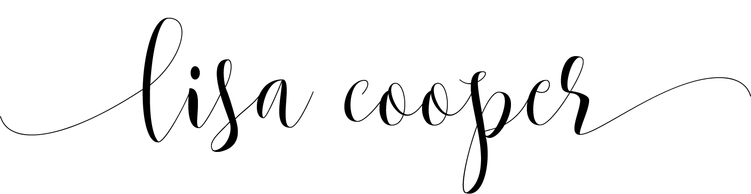

MAKEUP ARTIST




lisa@luminouslisaartistry.com

www.luminouslisaartistry.com
NYC/NJ
954.579.0711

FREELANCE HAIR/MAKEUP ARTIST
Provide Makeup/Hair services for private and corporate clients:
- Communicate with clients to identify wants/needs for their shoot
- Apply makeup in a professional manner, adhere to personal hygiene standards and stay current with latest products and best practices in the industry
- Recent corporate clients for video/commercial/print include:
  - “Butterfly” Film, Kaleidoscope Nine Productions
  - “Praxis Podcast”, Colours and Shapes Design
  - “Josh for Jersey” commercial/NBPro Media
  - “Audible/Heads Will Roll 2 BTS/Kate McKinnon & Emily Lynne”/Interviews + B-Roll footage, Beverly Boy Productions
  - ExEx.Ai Corporate Campaign
  - “Munich RE” Campaign for I & eye Productions
  - Hackensack Health Corporate Video, Plum.TV Productions
  - “The Book of Art” Pictorial/Coffee Table Book
  - “Christian Health” commercial/NBPro Media
  - “Josh Gottheimer for Congress” commercial/NBPro Media
  - Amy Perry, lead singer Saleh, for The Firing Squad/Epoch Times
  - “VAST Data” for Ruckus Marketing
  - Davidson Kempner Capital Management
  - “Dell/Credit Suisse” for East Coast Creative
  - Cole Schotz, LLC Law Firm
  - Studio Med Aesthetic NYC
  - “Camp Getaway” Season 1/Haymaker Media/Bravo TV
  - Playmakers/Dow Jones/WSJ for 160/90 Marketing
  - The Discovery Channel and Discovery En Espanol/OMG Marketing
  - New York Fashion Week, 2025
  - Atlantic City Fashion Week, 2020
  - INC Magazine for REP Interactive Group
  - Grace Kelly Music
  - MOEVIR Magazine

  - I am a Hair/Makeup Artist, specializing in Corporate Beauty, getting clients camera-ready for corporate videos, lifestyle shoots, corporate branding, and headshots. I also work in Creative Beauty, working on Indie Films, magazine/editorial shoots, and special events.
  - Profile
LICENSES
FACIAL SPECIALIST
State of FL (EXP 10/27)

ASSOCIATIONS
Professional Beauty Association (PBA) Member

BACHELOR FINE ARTS
University of Arizona
Major: Media Arts, Film/Television/Print
EDUCATION

EXPERIENCE

EXTENSIVE MAKEUP ARTIST PROGRAM: BEAUTY/FASHION
Nina MUA, NYC

HAIRSTYLING PROGRAM FOR MAKEUP ARTISTS
NINA MUA, NYC

